Week 1 – Practical Assignment



Class: EI1J

Name: Ivan Vasilev  
Studentnumber: 3452271

Name: Kristiyan Milanov  
Studentnumber: 3452263

Table of Contents

Table of Contents

**Requirements Gathering3**

Analyzing the requirements4

Visualizing the process5

Requirements Gathering

|  |  |
| --- | --- |
| Deliverable | Requested features |
| Automated Movement  Pick-up and drop-off  Breaks  Path Check | * The colour sensor will detect the black line and if the sensor detects the red line the right motor will spin up so that the robot enters the correct path again. And vice-versa if it detects the yellow line it will steer with the left motor right. * Meanwhile we use the IR Sensor to detect if there is an object upfront by sending IR waves and if they bounce back to the IR Sensor it means that there are objects upfront and if it is a person the robot will set the motor power to 0 and this way the robot will have stopped and prevented an accident. * The speed is easily manageable by changing the power percentage of the motors, from 1 to 100 %, also by assigning a negative value you can make the robot go in reverse. * Using the IR Sensor again we can detect if there is something upfront and if so the robot will stop, then if the object remains unmoved we will accept it as an object but if the object moves we will accept it as a person and wait for him/her to move and then continue following the path. * Using the motor in low power mode so that it retracts the claws slowly, we try to grip the object and lift it in the air, after that the robot will proceed following the given path. * When the drop off spot has been reached we untighten the grip and lower the object to the ground, and we mark the finish of the process. * If we see a white line using the colour sensor we engage a full-stop because if the robot goes out of path in real life the objects could be damaged. After that, we could try finding one of the coloured lines and using it go back to the black line path. |
|
|
|
| App | * The ev3 has built in Bluetooth and using that you can connect It to your mobile device and using the app control the robot. * If you press start the robot will engage its algorithm and try to follow the path until completion. * If you press pause it will wait to resume its algorithm. * The status will be updated on every algorithm cycle and be displayed on the worker’s phone. |

Analysing the requirements

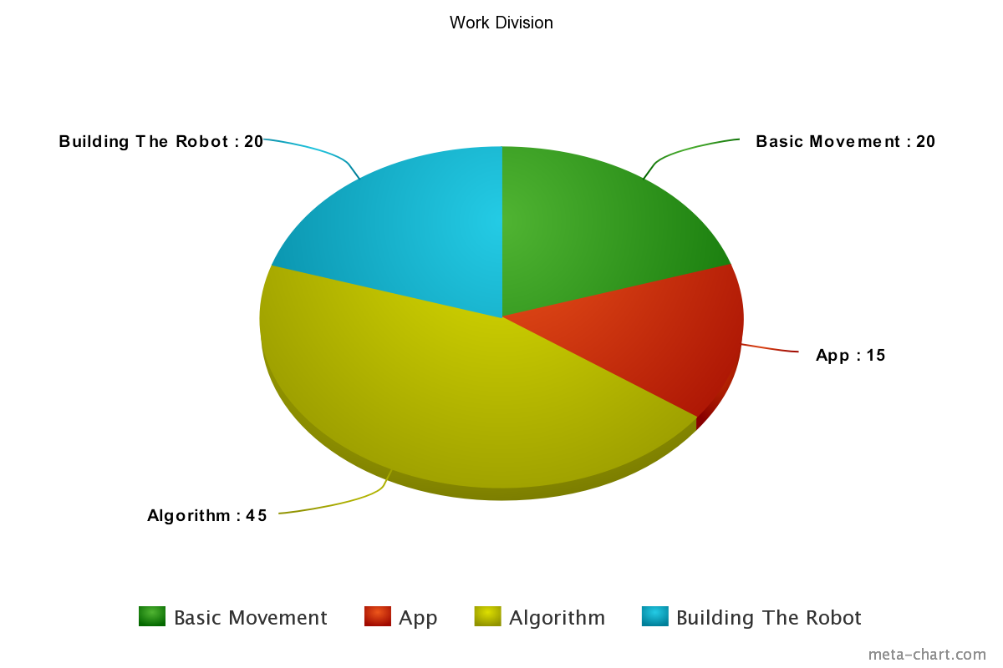

Visualising the requirements

